



THE MARITIME ACADEMY OF TOLEDO

ANNUAL REPORT 2022-2023

Submitted to ESC Central Office 2080 Citygate Drive

Columbus, OH 43219

By

Aaron Lusk

Superintendent

*Freedom to Succeed*

|  |  |  |
| --- | --- | --- |
| Annual Report 2020-2021  Table of Contents | | |
| Introduction | 1. Welcome Letter 2. Vision and Mission 3. Staff and Admin   Assessments  Enrollment  Attendance | Pages 3-9 |
| Section 1 | Special Accomplishments | Pages 10-14 |
| Section 2 | Performance and Academic Standards | Pages 15-17 |
| Section 3 | State Report Card | Pages 18-27 |
| Section 5 | Financial Information | Pages 28-31 |
| Section 6 | Unique Information | Pages 32-35 |



**The Maritime Academy of Toledo**

803 Water Street, Toledo, OH 43604

Phone: 419-244-9999 Fax: 419-244-9898

Website: www.[maritimeacademy.us](http://www.maritimeacademy.us)

Email: info@maritimeacademy.us

October

Dear Parents/Guardians:

It is with pleasure that I present to you the 2022-2022 Annual Report detailing accomplishments and areas of continued need for the Maritime Academy of Toledo.

The Maritime Academy of Toledo is one of Northwest Ohio's most innovative tuition-free public schools using nautical themes to educate students in grades 6-12. All students, referred to as "cadets," are challenged to achieve academic excellence and leadership skills in preparation for college and the world of work. We strive to become Northwest Ohio’s premier career tech center with a personalized learning experience.

Maritime courses of study ensure that students master grade-level standards and complete a high school diploma-based course of study. Differentiated instruction ensures that every Maritime student will experience academic growth in reading, writing, math, science, social studies, art, music, technology, and physical education.

The Academy is committed to ensuring students receive a rigorous, high-quality education which incorporates career education beginning in 7th grade. TMAT offers students a challenging Ohio standards-based education that promotes teamwork and moral leadership through maritime/nautical focused themes.

TMAT is committed to ensuring a safe and healthy learning environment through a strict code of conduct. The Academy is also committed to developing strong partnerships with families through a strong parent organization, volunteer program, regular conferences, and intervention strategy meetings.

Signature:

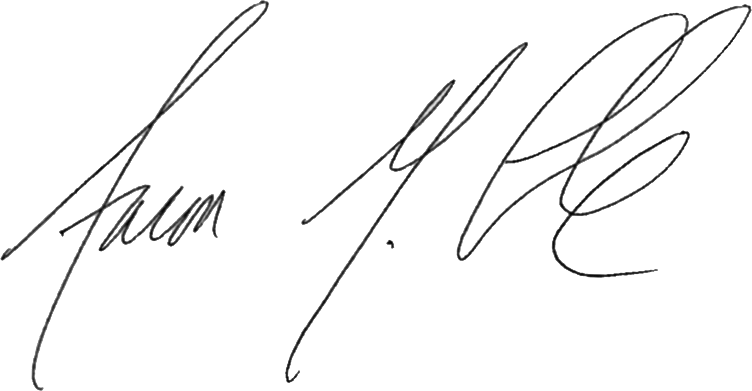

Superintendent

### Our Vision

It is our vision at the Maritime Academy of Toledo to shape future leaders by developing strong character and innovative minds.

### Our Mission:

### It is the mission of the Maritime Academy of Toledo to provide students with rigorous academic pathways, towards college or career, with a personalized learning experience.

### Our Philosophy:

WE BELIEVE in the education of the “whole child.”

WE BELIEVE every child is entitled to an education that supports the child's present level of knowledge, skills, and dispositions, and at the same time challenges the child to grow, develop, and learn to his or her maximum potential.

WE BELIEVE all children can learn.

WE BELIEVE good teaching practices support children's emerging interests, strengths, and talents.

WE BELIEVE it is critically important to plan for children's intellectual and personal growth based upon what they already know and can do.

WE BELIEVE in identification of the academic strengths and needs of students in the fifth grade to give them essential support throughout their time at the Maritime Academy.

WE BELIEVE strongly in our character education program “Welcome ABOARD” to teach valuable social skills that helps develop “RAD” Mariners.

|  |  |
| --- | --- |
| The Maritime Academy of Toledo  803 Water St.  Toledo, OH 43604 | |
| Telephone | 419-244-9999 |
| Fax | 419-244-9898 |
| IRN | 000770 |
| Website | www.maritimeacademy.us |
| Facebook | https://www.facebook.com/MaritimeAcademyofToledo/ |
| Inaugural School Year | 2006-2007 |

|  |  |
| --- | --- |
| The Maritime Academy of Toledo  Governing Board | |
| Chairperson | Paul Hubbard |
| Vice Chairperson | James Hartung |
| Director | Dr. William Davis |
| Director | Keith Jordan |
| Director | Tim Goligoski |
| Director | Kate Fineske |
| Director | Joy Goodner |
| Treasurer | Tony Swartz |
| Secretary | Kathy Simpson |

|  |  |
| --- | --- |
| The Maritime Academy of Toledo  Administration | |
| Superintendent | Aaron M. Lusk |
| Treasurer | Tony Swartz |
| Principal | Jacob Lofton |
| Business Manager | Kathy Simpson |

**ASSESSMENTS**

The Maritime Academy of Toledo utilizes several assessments to measure the academic proficiency and growth of our students. Utilizing and analyzing data from assessments is a very important part of your child’s education as it helps the teachers determine the best methods to teacher the content. Below is a summary of each of our assessments used at the Maritime Academy of Toledo.

**STAR Reading and Math Benchmarking System**

STAR Reading assesses the reading achievement of independent readers from reception to year 13 who have a sight vocabulary of 100 or more words and provides both criterion-referenced and norm-referenced scores. The STAR Reading item bank includes more than 5,000 carefully calibrated, standards-based items. STAR Reading assesses skills in five broad domains. The STAR Reading item bank’s thousands of items assess all the skills in the new reading curriculum from reception right through to the end of Key Stage 4. STAR Reading is innovative among reading assessments because it estimates a student’s oral reading fluency with high reliability and validity through his or her silent reading. STAR reports fluency as an Estimated Oral Reading Fluency (Est. ORF) score, complete with Est. ORF benchmarks. The Est. ORF benchmarks are consistent with the Hasbrouck and Tindal (2006) fluency benchmarks, which are the standard in the field.

STAR Math STAR Math assesses the math achievement of students in years 1 to 13. It provides both norm-referenced and criterion-referenced scores. Each test includes questions in four broad domains. The STAR Math item bank includes over 3,400 items that test all the skills in the new math curriculum from reception right through to the end of Key Stage 4.

**Ohio State Tests:**

State achievement tests tell us how well our students are growing in the knowledge and skills outlined in Ohio’s Learning Standards. These tests help guide and strengthen future teaching so we can be sure that we are preparing our students for long-term success in school, college, careers and life. Test results also allow citizens to know how their local schools are performing compared to others around the state.

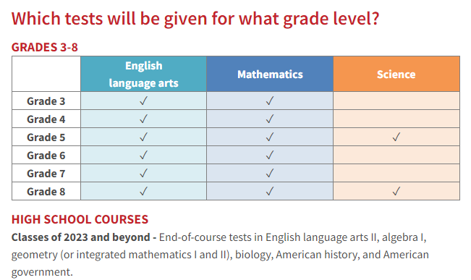

**ACT**

The ACT is a standardized test used for college admissions in the United States. It is currently administered by ACT, a nonprofit organization of the same name. The ACT test covers four academic skill areas: English, mathematics, reading, and science reasoning. It also offers an optional direct writing test. It is accepted by all four-year colleges and universities in the United States as well as more than 225 universities outside of the U.S. All students at the Maritime Academy of Toledo will take the ACT, for free, during their Junior year of High School.

**ASVAB**

The Armed Services Vocational Aptitude Battery (ASVAB) is a [multiple choice](https://en.wikipedia.org/wiki/Multiple_choice) test, administered by the [United States Military Entrance Processing Command](https://en.wikipedia.org/wiki/United_States_Military_Entrance_Processing_Command), used to determine qualification for [enlistment](https://en.wikipedia.org/wiki/Enlistment) in the [United States Armed Forces](https://en.wikipedia.org/wiki/United_States_Armed_Forces). All Juniors at the Maritime Academy can choose to take the ASVAB test which will give them quality information applicable to any career.

**ENROLLMENT**

The Maritime Academy of Toledo prides itself on the diversity of our student body as shown in the table below. Throughout the 2022-2023 school year, our students on IEPs were 30% of our student population while our students on free and reduced lunch totaled 86.1%.

SCHOOL MOBILITY AND ATTENDANCE

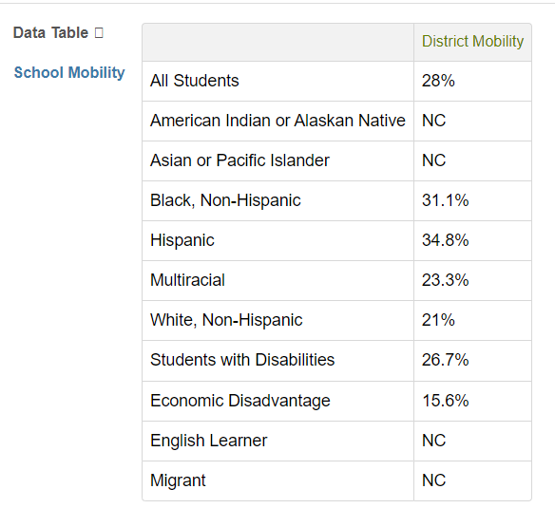

The tables above show the percentage of students who did not attend Maritime Academy for the entire school year which was 28% up from 27.4% the previous year. This makes it difficult to teach consistent curriculum considering so many students move in and out of the school during the year. In addition, 26.7% of our students with disabilities were not at The Maritime Academy for the entire school year.

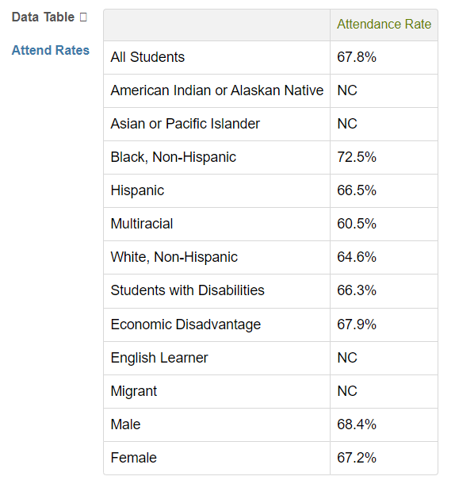

The attendance rate for The Maritime Academy of Toledo had declined significantly during the pandemic and the 2022-2023 school year was no exception. The attendance rate ended at 67.8% but should be within the 80% or 90% range for more appropriate attendance levels. In addition, the Maritime Academy of Toledo had a chronic absenteeism rate of 81.4%. This is significantly higher than the state average of 29%. What this means is that 81.4% of our student population missed at least 10% of the school year. There is no doubt that student attendance must be a priority moving forward in order to increase academic achievement.



Contents:

A: Why Choose Maritime?

B: 2023 Graduates

C: Community Partnerships

D: Teacher Experience

Section 1:

Special Accomplishments

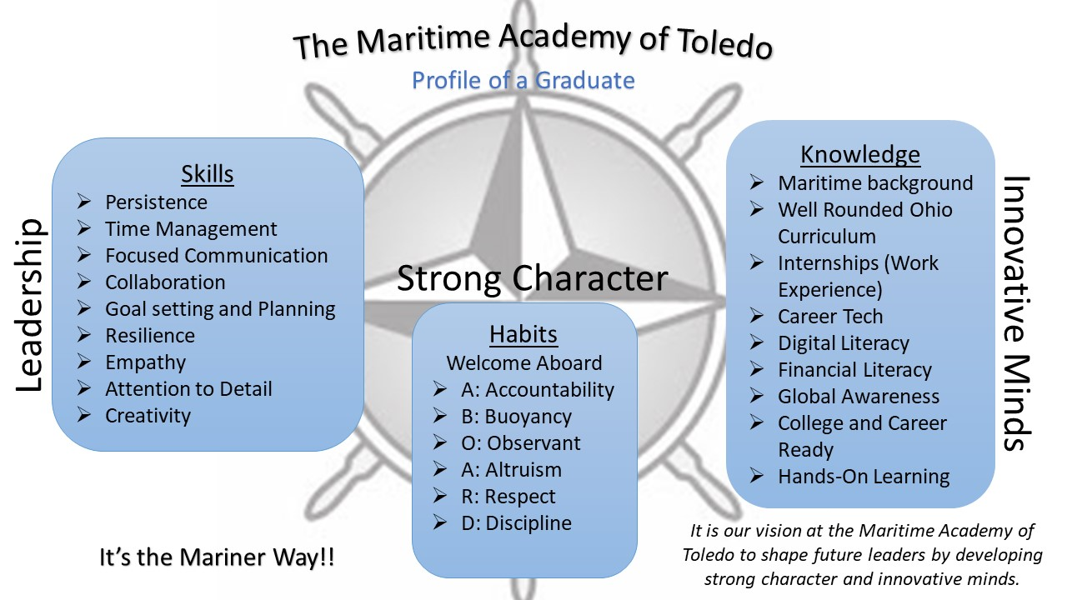

The Maritime Academy of Toledo is one of the most unique and innovative tuition-free public schools in the country—integrating nautical/maritime themes and experiences across the curriculum to educate students in grades 6-12. All Maritime Academy students are challenged to achieve academic excellence and develop leadership skills in preparation for college and the world of work. The Academy is one of only a few marine deck, engine, and culinary High School Career Tech Education program in the U.S., students have the opportunity to graduate with 20 semester hours of college credit, a passport, Transportation Worker Identification Card, Merchant Marine Credential (Basic Firefighting, Personal Survival Techniques, Personal Safety and Social Responsibility, and CPR/First Aid, making them ready to begin a lucrative career at sea, on tugboats, freighters, barges, oil rigs, and in shipyards. The Academy’s Maritime Career Tech Education Program is the first and only in the State of Ohio and one of the few in the U.S., with its mission is to cultivate a new generation of racially and gender diverse competent, job-ready mariners for the maritime industry. The Culinary Career Tech field prepares students to achieve Pro Start and Serve Safe credentials which provides each one with an advantage in hiring. The Marine Environmental Science program, will allow our graduates to pursue a degree in up to 19 different fields ranging from Marine Biology, Environmental Science, Landfill Management to employment in water and sewage treatment facilities (See Page 34 for a more thorough explanation of our Career Tech Programs.)

2023 Graduates

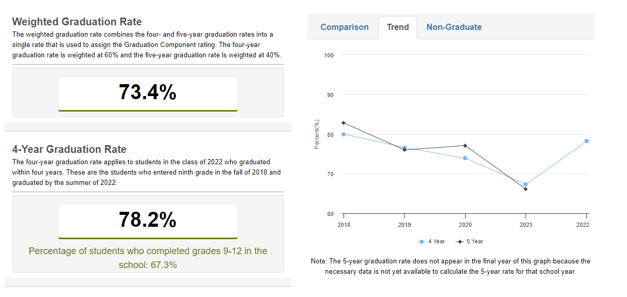

**COMMUNITY PARTNERSHIPS**

To aid in its mission and vision, TMAT has formed dynamic partnerships with the City of Toledo, The National Museum of the Great Lakes and the Toledo Port Authority. The school also partners with members of the local community, as well as other marine-related organizations and industries around the world.

1). Maintained a partnership with Owens Community College to provide college credits for CTE programs

2). Maintained an international partnership with V-Step, from the Netherlands for software updates on the Class A Full Mission Bridge and 8-Station (16 students) Radar Classroom simulators

3). Continued a partnership with the Toledo Building Trades

4). The pandemic prevented our cadets from sailing on the USS Brig Niagara for three-week internship in the summer but a partnership with the Niagara has been maintained, however.

5). Hosted several career days attended by various shipping companies, shipping union representatives, military branches, NW Ohio trade organization, environmental science careers, and culinary employment possibilities.

6). Provided academic assistance afterschool program and virtual summer camps (navigation simulation, boating, swimming, kayaking, boat building, art, test prep, math and language arts tutoring, guitar, physical education, basketball, track, culinary and dance)

7). We held several career tech education industry advisory committee meetings to advise and guide both Culinary and Maritime Occupations programs.

**TEACHER EXPERIENCE**

The Maritime Academy of Toledo, similar to other Community Schools, has had a high rate of teacher turnover during the pandemic.

Consider the following:

During the 2015-2016 school year 72% of the teachers at the Maritime Academy of Toledo had 4 years or less of experience.

During the 2020-2021 school year 26% of teachers at The Maritime Academy of Toledo had 4 years or less of experience.

During the 2021-2022 school year 46.7% of the teachers at The Maritime Academy of Toledo had 4 years or less of experience. A nationwide teacher shortage has affected the makeup of the staff at The Maritime Academy.

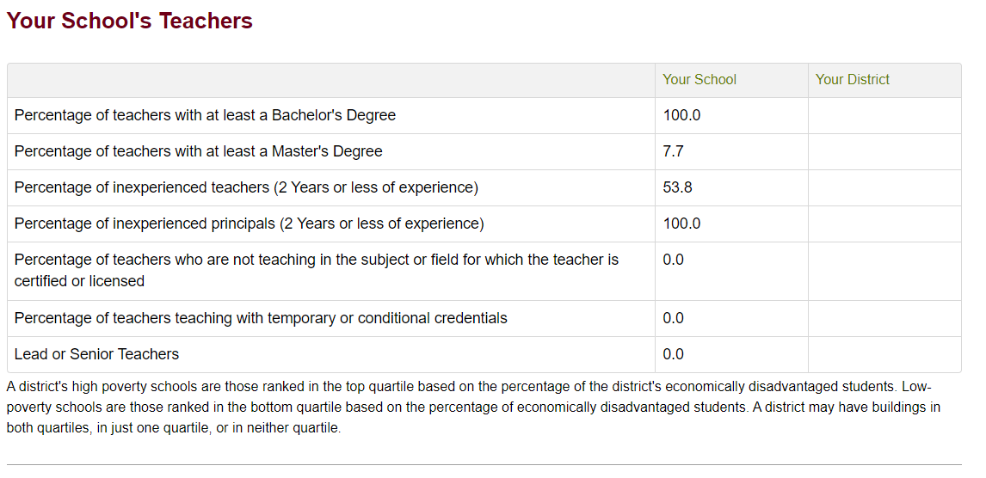



Section 2:

Performance and Academic Standards

Contents:

A: Maritime Improvement Plan Goals

**One Plan Information**

1. Goal #1 of 3
   1. Root Cause Analysis

In December 2021 the Maritime Academy of Toledo had a turnover of 20% of our academic staff and replaced 7 academic staff members with 8 new staff members. With these 8 new academic staff members 88% of these staff members have long term substitute licenses in areas other than what they are teaching. With these changes the academic improvement plans had to start over because less than 50% of the teachers had curriculum maps at the beginning of the 2021-2022 school year. Additionally, at the start of the 2021-2022 50% of the teachers were new, at Maritime, and did not have curriculum maps. Here at The Maritime Academy of Toledo, we need to have both vertical and horizontal learning alignment, across both grades and content areas. This alignment should focus on informational text and higher depth of knowledge questioning strategies. It is important that we allow teachers the time to plan and monitor curriculum in order to allow students to excel through progressive content in the English classroom.

* 1. SMART Goal Statement

By **05/31/2026** we will improve the performance of **All Students**, **All Grades** students at/in **Maritime Academy of Toledo, The** to **increase 40.00 SGP**in **Informational Text** using **District Short Cycle Assessments**.

* 1. Student Measures
     1. Student Measure #1

Every **Quarter**, **Informational Text - District Short Cycle Assessments** of **All Students** will be measured, with a final improvement of **increase 40.00 SGP** at the end of the plan.

* 1. Strategies and Actions
     1. Strategy #1: Curriculum, Instruction and Assessment
        1. Strategy Level: Level 1
        2. Description:

Teacher Clarity: Teacher clarity relates to organization, explanation, examples and guided practice, and assessment of student learning. It can involve clearly communicating the intentions of the lessons and the success criteria. According to Hattie, teacher clarity is the ability to name all of one’s planning steps about goals, content, methods and media and using examples to explain them to students. Before instruction can begin, the teacher must articulate success criteria for achievement to students (Hattie, 2018, p. 62). To successfully provide clarity during instruction, teachers must have a deep understanding of what they are teaching and why, how to provide effective instruction through explicit delivery of content, and what successful learning looks like for different learners. It is important to note that these elements begin with explicit and thoughtful planning.

* + - 1. Action Steps
         1. Plan Year: 2023, Action Completion: 07/01/2022

Develop onboarding system for all new staff and teachers to teach the Maritime Way.

* + - * 1. Plan Year: 2023, Action Completion: 08/12/2022

Staff surveys (Developed by the Building Leadership Team) will be conducted each quarter to determine Teacher Clarity implementation success and staff buy in.

* + - * 1. Plan Year: 2023, Action Completion: 08/12/2022

All NEW teachers and staff will be trained on chapters 1-4 of the Teacher Clarity Playbook.

* + - * 1. Plan Year: 2023, Action Completion: 08/12/2022

Review and Revise Curriculum Maps (Start: ELA/Social Studies, then Math & Science) to ensure curriculum and assessments are aligned to Ohio Learning Standards

* + - * 1. Plan Year: 2023, Action Completion: 12/16/2022

Utilizing the Teacher Clarity Playbook the Teacher Clarity Building Leadership Team will help teachers create effective formative assessments that align to standards

* + - * 1. Plan Year: 2023, Action Completion: 05/26/2023

Throughout the 22-23 school year administration staff will conduct walkthroughs to determine the implementation success of the Teacher Clarity Process.

* + - * 1. Plan Year: 2024, Action Completion: 08/11/2023

By 8/15/2024 utilizing walkthrough data from the previous year staff will be individually trained in implementing success criteria and how to align the criteria with formative and summative assessments.

* + - * 1. Plan Year: 2024, Action Completion: 05/31/2024

Throughout the 23-24 school year the principals will conduct walkthroughs and provide feedback on the integrity of implementation of Teacher Clarity.

* + - * 1. Plan Year: 2024, Action Completion: 05/31/2024

Utilizing the Teacher Clarity Process teachers will use formative assessment to drive instruction.

* + - * 1. Plan Year: 2024, Action Completion: 08/16/2024

Utilizing the Teacher Clarity Process teachers will align their assessments to the standards and make sure that the assessments have high level of DOK levels.

* + - * 1. Plan Year: 2024, Action Completion: 08/11/2023

All teachers will be given professional development on how to incorporate informational text in their classrooms.

* + - * 1. Plan Year: 2025, Action Completion: 05/30/2025

Create evaluation team for implementation and determining effectiveness.

* + - * 1. Plan Year: 2025, Action Completion: 05/30/2025

Professional Learning Communities (PLCs), with BLT support, will learn to implement their chosen evidence-based strategy as it is intended.

* + 1. Strategy #2: Operations
       1. Strategy Level: Level 1
       2. Description:

The Schoolwide Enrichment Model-Reading (SEM-R) is an instructional model in which all students are exposed to a variety of books, spend time independently reading self-selected books, and meet with their teachers for a few minutes every week or two to discuss reading strategies and respond to higher-order questions. The program is implemented 40-45 minutes daily or 3 hours per week in regular English language art classes.

* + - 1. Action Steps
         1. Plan Year: 2023, Action Completion: 06/07/2024

By May 2021 The Maritime Academy of Toledo will have a system developed for implementing and training all staff on the reading enrichment program.

* + - * 1. Plan Year: 2024, Action Completion: 05/30/2025

By May 30th, 2025 80% of staff will be utilizing the reading enrichment system as evidenced through classroom walkthroughs.

* + - * 1. Plan Year: 2024, Action Completion: 08/15/2025

All new staff will be trained on the reading enrichment system and 100% of teachers and staff will utilize the system as measured through walkthrough data.

* 1. Adult Measures
     1. Adult Measure #1
        1. Operations

Every **Semester**, **Reading/Literacy - Walkthrough Data** of **All Staff** will be measured, with a final improvement of **increase 100.00 %** at the end of the plan.

Goal #2 of 3

1. Root Cause Analysis

Based on data including the records review in December 2021 there was clear evidence that progress monitoring and specialized instruction was not taking place in the general education classroom or elsewhere. In January 2022 8 IEPs and 9 ETRs were out of compliance with federal law after a full records review was conducted by our sponsor The ESC of Central Ohio. There was no one that understood the importance of progress monitoring in the special education department. Therefore, the root cause of a lack of achievement for students with special needs is because there was no defined system which would include a policy and procedures manual about what data gets reported by special education staff to inform instruction in the general education classroom.

1. SMART Goal Statement

By **05/26/2026** we will improve the performance of **Students with Disabilities**, **6th-12th** students at/in **Maritime Academy of Toledo, The** to **increase 10.00 %** in **Math** using **special education profile**.

1. Student Measures
   1. Student Measure #1

Every **Quarter**, **Math - District Short Cycle Assessments** of **Students with Disabilities** will be measured, with a final improvement of **increase 40.00 SGP** at the end of the plan.

1. Strategies and Actions
   1. Strategy #1: Curriculum, Instruction and Assessment
      1. Strategy Level: Level 4
      2. Description:

Multi-Tiered System of Support (Academic)  
  
MTSS is a framework many schools use to provide targeted support to struggling students. The goal of MTSS is to intervene early so students can catch up with their peers. It screens all students and aims to address academic and behavior challenges.  
  
MTSS assists:  
  
Promoting school participation in the focus to align the entire system of initiatives, supports, and resources  
Relying on a problem-solving systems process and method to identify problems, develop interventions, and evaluate the effectiveness of the intervention in a multi-tiered system of service delivery  
Transforming the way schools provide support and setting higher expectations for all students through intentional integration of instruction and intervention services and supports so that systemic changes are sustainable and based on standards-aligned classroom instruction  
Endorsing Universal Design for Learning instructional strategies so that all students have opportunities for learning through differentiated content (i.e., teachers reacting responsively to a learner’s needs), processes, and products  
Challenging all school staff to change the way in which they have traditionally worked both in and out of the classroom  
Using schoolwide and classroom research-based positive behavioral supports for achieving important social and learning outcomes  
Supporting high-quality standards and research-based, culturally and linguistically relevant instruction with the belief that every student can learn and excel, including students of poverty, those who are gifted and high achievers, students with disabilities, English learners, and students from all ethnicities evident in the school and cultures  
Integrating a data collection and assessment system including universal screening, diagnostics, and progress monitoring, to inform decisions appropriate for all students  
Implementing a collaborative approach to analyze student data and work together in the intervention process

* + 1. Action Steps
       1. Plan Year: 2023, Action Completion: 08/18/2023

We will identify staff and time for Tier 2 and Tier 3 instruction and defining the expectations to include roles, and responsibilities including a method of tracking data and staff needed.

* + - 1. Plan Year: 2023, Action Completion: 12/15/2023

To create a dynamic system of academic support by December 2023 the Building leadership team will determine what data is used, considering formative, summative, state and/or STAR benchmark.

* + - 1. Plan Year: 2023, Action Completion: 06/28/2024

Determine who the co-planning teams are, what they are discussing and identify their next steps.

* + - 1. Plan Year: 2023, Action Completion:

Develop or provide resources and tools for teams to use in data collection, data analysis and subsequent next steps.

* + - 1. Plan Year: 2024, Action Completion: 08/15/2024

100% teachers will receive professional development on the three chosen areas of mnemonics, vocabulary, and graphic organizers which will be used in TIER 2 and 3.

* + - 1. Plan Year: 2024, Action Completion: 12/20/2024

By December of 2024 100% of 6th-9th grade teachers will be trained and utilizing a multi-tiered system of support.

* + - 1. Plan Year: 2024, Action Completion: 05/30/2025

By May, 2025 all teachers in grades 6-12 will be trained and utilize a multi-tiered system of support.

* + - 1. Plan Year: 2024, Action Completion: 07/31/2025

Throughout the 25-26 school year the Principals will conduct walkthroughs and utilize the data to determine the efficacy of the system and academic growth.

* + - 1. Plan Year: 2024, Action Completion:

Instructional staff and administrators will receive on-going job-embedded training.

* 1. Strategy #2: School Climate and Supports
     1. Strategy Level: Level 1
     2. Description:

A universal, school-wide prevention strategy aimed at reducing behavior problems that lead to office discipline referrals and suspensions, and change perceptions of school safety. Students in the SWPBIS schools received significantly fewer school suspensions than students in schools that did not receive SWPBIS training. Perceptions of safety improved in the schools that implemented SWPBIS, but declined in the schools that did not implement SWPBIS.

* + 1. Action Steps
       1. Plan Year: 2023, Action Completion: 08/11/2023

Renew apps such as PBIS Rewards and SWIS by the beginning of September.

* + - 1. Plan Year: 2023, Action Completion: 08/18/2023

Staff training for PBIS team for new and returning staff in August.

* + - 1. Plan Year: 2023, Action Completion: 08/18/2023

Create staff incentives for teaching PBIS lessons and acknowledgements throughout the school year Communicate meeting notes to the rest of the staff during monthly BLT share-outs and bi-weekly staff meetings Staff survey to determine consistency amongst staff.

* + - 1. Plan Year: 2023, Action Completion: 08/18/2023

Plan and implement new teacher training and orientation Plan for student orientation and Open House parent night

* + - 1. Plan Year: 2023, Action Completion: 09/29/2023

The Positive Behavior support team will develop a pamphlet, video, or other information to teach students how to properly wear the Maritime uniform.

* + - 1. Plan Year: 2024, Action Completion: 12/20/2024

The Positive Behavior Intervention Team will develop a mentoring group and incorporate it into the Leadership Corps (Student Council).

* + - 1. Plan Year: 2024, Action Completion: 12/20/2024

Create staff incentives for teaching PBIS lessons and acknowledgements throughout the school year

1. Adult Measures
   1. Adult Measure #1
      1. Curriculum, Instruction and Assessment

Every **Semester**, **Math - Walkthrough Data** of **Math Teachers** will be measured, with a final improvement of **increase 100.00 %** at the end of the plan.

* 1. Adult Measure #2

Every **Semester**, **academic counseling sessions - Completion of Task** of **Ninth Grade Staff** will be measured, with a final improvement of **increase 100.00 %** at the end of the plan.

* 1. Adult Measure #3

Every **Semester**, **teamwork - Participation** of **All Staff** will be measured, with a final improvement of **increase 100.00 %** at the end of the plan.

Goal #3 of 3

1. Root Cause Analysis

The Maritime Academy of Toledo has created many systems to provide communication between leaderships teams and stakeholders but are still at the beginning phases of this development. Developing these new systems takes time and "trial and error" and no one thought to ask the stakeholders how they would best receive or understand this information to use on a daily or weekly basis. Therefore, the root cause of the lack of "progress monitoring" of communication amongst leadership teams proves to be the lack of stakeholder surveys or other methods to determine the best way for stakeholders to receive and use information that is coming from leadership teams such as TBTs, and BLTs. We have no data that shows that stakeholders have processed that information. This fact that no data exists means that progress monitoring the communication process of BLTs and TBTs makes it difficult and make decisions about what action to take or what should be completed next.

1. SMART Goal Statement

By **05/26/2026** we will improve the performance of **All Students**, **High School** students at/in **Maritime Academy of Toledo, The** to **increase 10.00 %** in **Graduation** using **State Report Card - Graduation Rate**.

1. Student Measures
   1. Student Measure #1

Every **Semester**, **Graduation - Course Credits Earned** of **All Students** will be measured, with a final improvement of **increase 80.00 %** at the end of the plan.

1. Strategies and Actions
   1. Strategy #1: Leadership, Administration, Governance
      1. Strategy Level: Level 4
      2. Description:

Developing a system of Career Development by providing opportunities for students to engage in career focused activities across all pathways at each grade level.  
Career Planning, Decision-Making, & Transition (e.g.: understand career interests, engage in career-based learning experiences, explore and identify education and training options beyond high school aligned with career interests, learn how to adjust career plans according to shifts in the economy and interests).

* + 1. Action Steps
       1. Plan Year: 2023, Action Completion: 08/11/2023

Develop an orientation system for new students to learn the school expectations and career opportunities and pathways.

* + - 1. Plan Year: 2023, Action Completion: 08/11/2023

Develop implementation plan with specific tasks for each level of implementation.

* + - 1. Plan Year: 2023, Action Completion: 08/18/2023

Develop or provide resources and tools for teams to use in data collection, data analysis and subsequent next steps.

* + - 1. Plan Year: 2023, Action Completion: 09/29/2023

Develop a plan for monthly parent information nights to provide career guidance and opportunities for relationship building.

* + - 1. Plan Year: 2023, Action Completion: 12/15/2023

Develop a system of 2 X 10 conversations focusing on building teacher relationships and graduation plans.

* + - 1. Plan Year: 2023, Action Completion: 12/15/2023

Develop a system to reduce the amount of students receiving success plans by 10% from the previous semester.

* + - 1. Plan Year: 2023, Action Completion: 05/31/2024

Identify the format of the infosheet/newsletter and who is responsible for creating the infosheet/newsletter for career guidance and development.

* + - 1. Plan Year: 2023, Action Completion: 08/15/2025

Instructional staff and administrators will receive on-going job-embedded training. Determine current levels of teacher knowledge and implementation of graduation plans and success plans.

* + - 1. Plan Year: 2024, Action Completion: 08/16/2024

Create annual records review process with HS students and guidance staff.

* + - 1. Plan Year: 2025, Action Completion: 08/15/2025

Develop credit recovery process.

* + - 1. Plan Year: 2025, Action Completion: 12/19/2025

Determine mechanism for monitoring effectiveness of career guidance implementation.

* 1. Strategy #2: Operations
     1. Strategy Level: Level 4
     2. Description:

Teacher Estimates of Achievement: Hattie Effect size 1.29  
Teachers that build positive relationships with, and know their students, are much more likely to have students achieve at a higher level. For example, if a teacher has a positive relationship with a student, then that student is likely to try harder, persist longer, take risks and retry after failure. From the teacher's perspective, they are more likely to allocate work that is appropriate for the students in question, and select an instructional style that gets the most out of the students. Student-teacher relationships significantly impact teacher effectiveness and student achievement. Teacher relationship variables were among the most influential factors on student performance with an effect size of .52. These include empathy, warmth, encouragement, authenticity, and respect for student backgrounds.

* + 1. Action Steps
       1. Plan Year: 2023, Action Completion: 08/01/2022

Develop customized onboarding process for new hires that addresses the identified needs of the district/building.

* + - 1. Plan Year: 2024, Action Completion: 08/18/2023

Develop or provide tools to monitor changes in adult practices.

* + - 1. Plan Year: 2025, Action Completion: 08/16/2024

Introduce SEL strategies to building/teachers.

1. Adult Measures
   1. Adult Measure #1
      1. Leadership, Administration, Governance
      2. Every **Semester**, **graduation plans - Implementation Data** of **All Staff** will be measured, with a final improvement of **increase 100.00 %** at the end of the plan.



Section 3:

Academic and Survey Data

Contents:

1. State Report Card
2. Tiered Fidelity Inventory for the PBIS system

**Academic Achievement: Ohio State Report Card**

The 2022-2023 school report card were released in September of 2023. The Maritime Academy of Toledo has made gains in Progress and Gap Closing which raised our overall school rating from 1 star to 2.5 stars which provides a foundation in which to continue to strengthen and raise student achievement.

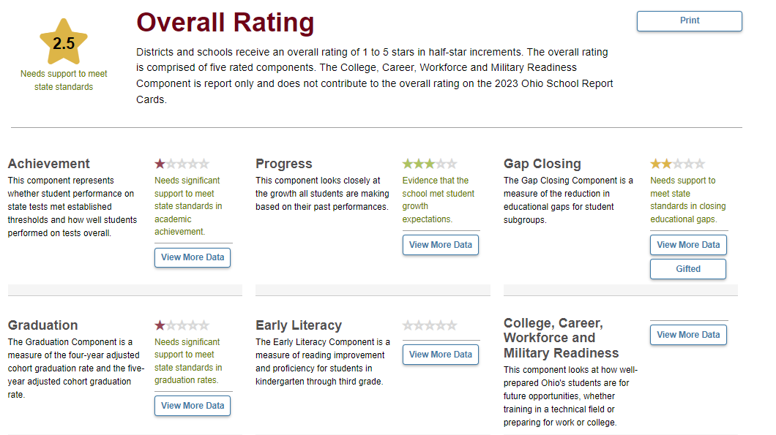

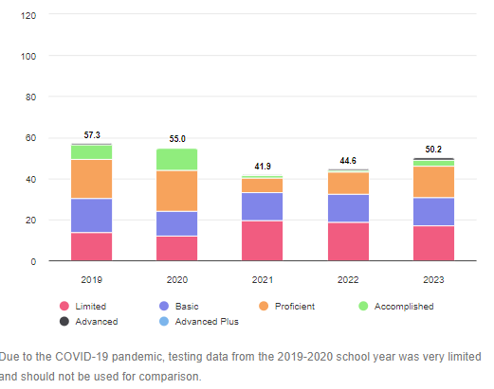

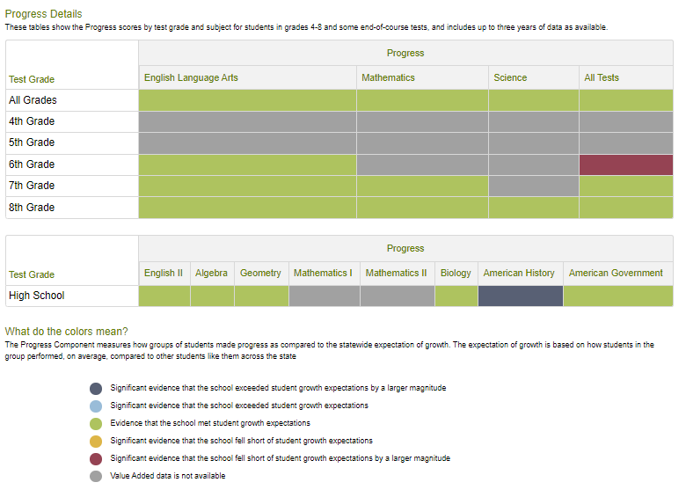

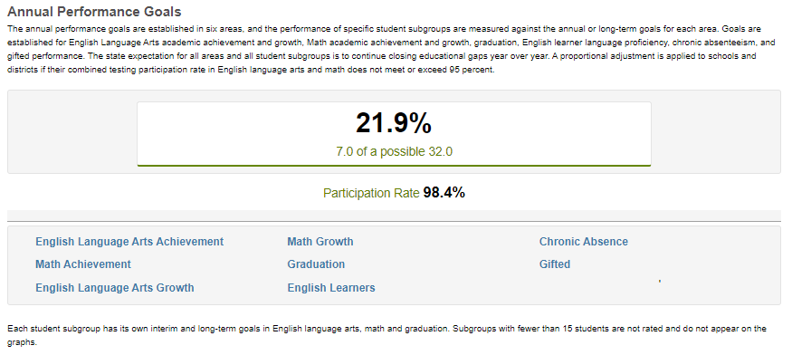

|  |  |  |  |
| --- | --- | --- | --- |
| Maritime Academy Of Toledo, The  Toledo, Ohio | | | |
|  | | | |
| Date  Completed | Tier 1 | Tier 2 | Tier 3 |
| 2/24/2022 | 63% | NA | NA |
| 11/16/2022 | 67% | NA | NA |
| 3/24/2023 | 80% | NA | NA |

On March 24th, 2023 Tamie Cruz, a representative from the State Support Team Region 1, performed an assessment on the implementation of our Positive Behavior Intervention Support system. The result of the assessment showed significant improvement in the implementation of the school wide behavior programs. Even with the improvement we will continue to implement the school wide practices for the 2023-2024 school year.

1). Financial Status

2). Federal Funds

Section 5:

Financial Information



Contents:

A: Federal Title Funds

B: Classroom Instruction Spending Data

C: Spending per Pupil Data

### 2022-2023 Financial Status of the Maritime Academy of Toledo

### For the 2022-2023 school year the Maritime Academy of Toledo once again earned a clean, “No Findings,” financial audit from the State Auditor’s office. The Maritime Academy has had “Clean Financial Audits” from the state of Ohio every year since 2011.

|  |  |  |
| --- | --- | --- |
| Funds | Beginning Balance | Ending Balance |
| General Fund | 823,159.08 | $668,364.20 |
| Permanent Improvement | -$11,577.78 | $0.00 |
| Food Service | $42,340.95 | $22,437.55 |
| Satin Gavel Scholarship Fund | $7,090.00 | $6,090.00 |
| Leadership Fund | $1,280.62 | $1,280.62 |
| Rotary Uniform Fund | $3,530.54 | $3,530.54 |
| Class Fund | -$390.92 | $0.00 |
| Prom Fund | $1,695.22 | $981.67 |
| Student Activities Fund | $1,349.64 | $2,679.77 |
| Cadet Chronicle Fund | $767.66 | $376.74 |
| Culinary Fund | $4,544.77 | $4,822.35 |
| Athletic Fund (Basketball) | $90.00 | $678.57 |
| Tall Ships Fund | $7,040.00 | $7,040.00 |

|  |  |
| --- | --- |
| Federal Funds | |
| $255,608.80 | Title 1 |
| $18,125.66 | Title 2 |
| $30,789.53 | Title 4 |
| $71,877.62 | Title 1 non-competitive |
| $137,180.82 | IDEA Part B |
| $35,116.89 | Expanding opportunities |
| $1455,197.58 | ARP ESSER |
| $16,540.02 | ARP IDEA |
| Total: $2,020,436.20 | |



Contents:

1. Career Tech Pathways

Section 5:

Career Tech Information

**Career Technical Education**

|  |  |
| --- | --- |
| **Maritime Occupations** | TMAT was the first Maritime High School in the U.S. to offer a Career Technical Education (CTE) Program in Maritime Occupations. It is a 4 year program with 9th graders taking a course called Maritime Skills, learning the basics of various maritime industries and its terminology, as well as having the chance to earn their Ohio Safe Boaters License. Further specialization is offered for 10th – 12th graders that decide to stay in the CTE program. Deck and Engine fundamentals are equally taught and cadets attend the local community college every Friday to learn welding, small engine repair, electrical and circuitry and diesel engines. This is combined with full semesters of seamanship skills, navigation, ships systems, boat building and other “maritime” core courses. Course work culminates as seniors as they may earn their Coast Guard certified STCW-BST credential. The senior cadets may receive their TWIC cards, US Passports and Merchant Mariner Credentials. This “job ready” approach have assisted several of our cadets in receiving job offers from various Great Lakes shipping companies and others have been admitted into the Great Lakes Maritime Academy, in Traverse City, Mi. Again, the bottom line for that program is opportunity, so the cadets in this program may earn several industry credentials and will graduate “job ready”.  In School Internship:   * Tall Ship Niagara – intern aboard the brig for a 2 – 3 week total immersion in sail training. * Prerequisites: Must compose various letters and have a letter of recommendation   Post Graduate Apprenticeship Opportunities:   * SIU (Seafarers International Union) – 9 month program for entry level candidates with promise of employment after program completion. * Prerequisites: Must be 18 years or older, have no criminal record, drug free, pass USCG physical * STAR Center Engineering Tech Program – 24 month program that will advance the individual from entry level to 3rd Assistant Licensed Engineer * Prerequisites: Must pass an entry academic and aptitude selection screening, must be 18 years or older, a U.S. citizen, have no criminal record, drug free, pass USCG physical |
| **Culinary** | The culinary arts program prepares cadets for a career in food service, food management, or hospitality. The cadets earn ceetificates in ServSafe and ProStart, which will give them precedence in the Culinary industry. |
| **Marine Environmental Science** | The Marine Environmental Sciences CTE program is a 3-year program. The program aims to prepare students to either obtain positions in water treatment plants or pursue degrees in environmental science. There are many different careers related to environment science: environmental engineers, wildlife biologists, park rangers, community outreach, environmental law, research, etc. Year 1 focuses on natural resources. Students will take courses at The Source in leadership and supervision. Year 2 is an introduction to environmental sciences. The students will take an OSHA Safety course and an environmental sciences course at Owens. Year 3 is Wildlife Zoology and Fisheries. The students will take an environmental science lab and an environmental law class at Owens. The students will participate in many service projects including Clean Your Stream , Student Watershed Watch, and Get the Lead Out. Students will obtain an OSHA certificate and Ohio EPA approved certificates through OTCO. |

Future Career Tech Programs

Dental Assistant

Welding